SS8H6c. Analyze the impact of Reconstruction on Georgia and other southern states, emphasizing Freedmen’s Bureau; sharecropping and tenant farming; Reconstruction plans; 13th, 14th, and 15th amendments to the constitution; Henry McNeal Turner and black legislators; and the Ku Klux Klan.
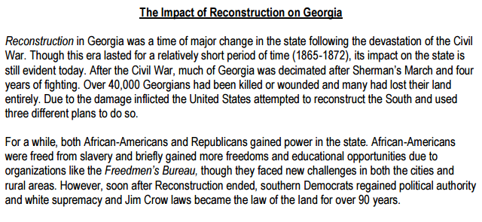
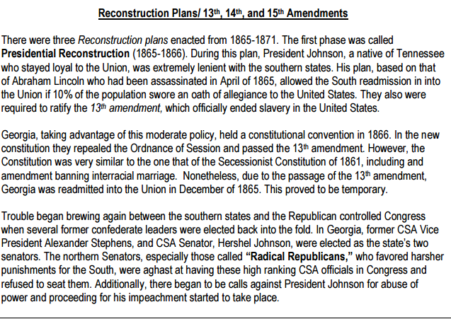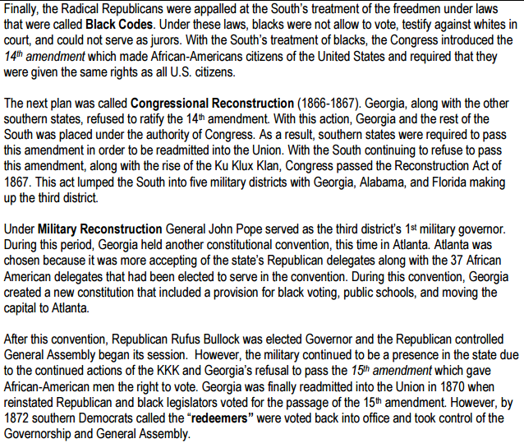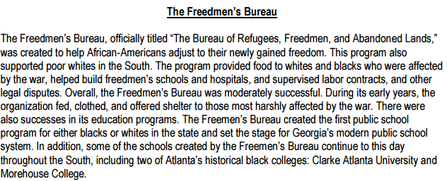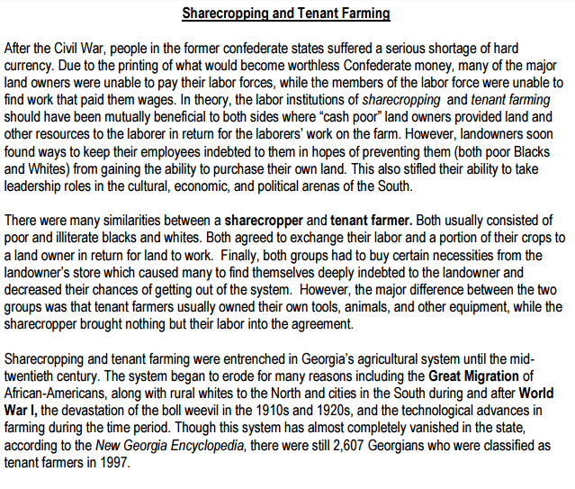
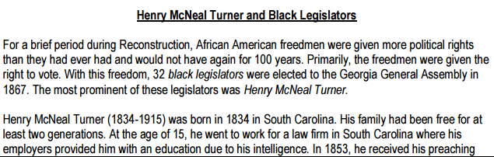
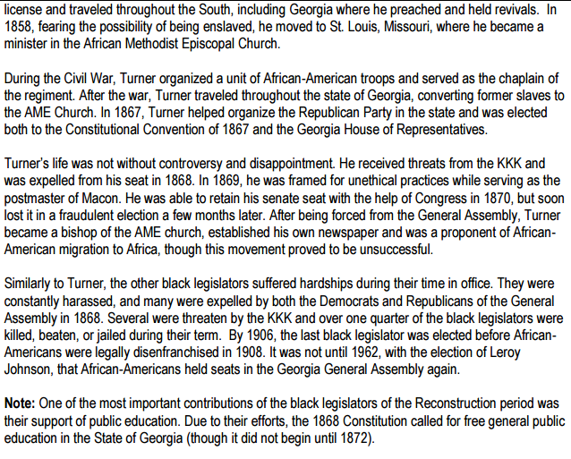
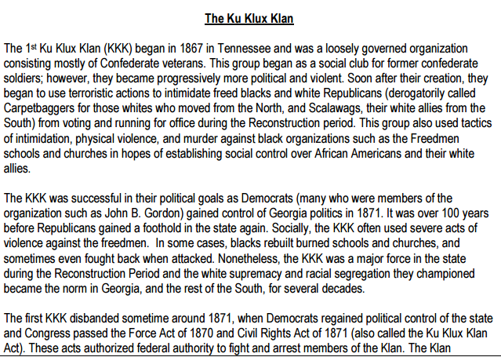
resurfaced in its second incarnation in 1915.

